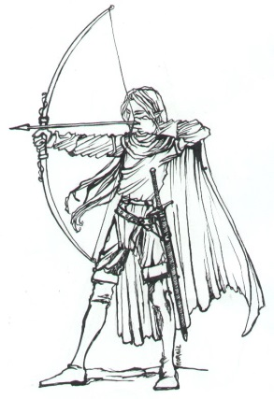
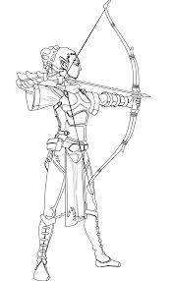
Allington Castle Archers
Medieval Challenge
All unsighted Archers shooting wooden arrows
are cordially invited to shoot on Sunday 10th May 2020 at the stunning Allington Castle.
Commencing at the 10th hour of the day.
There will be a number of medieval themed targets set at varying distances.
The wearing of medieval costume preferred but not obligatory.
Light refreshments shall be provided all day at the presentation of a small donation. Please provide your own repast at the lunching hour or partake of a
pulled pork and stuffing roll for a small fee of 2 gold coins.
Thy entry fee shall be 10 gold coins.
Please note:
There is absolutely no entry to the castle before 8.00am. Please do not turn up early and block the road outside of the castle.
Please do not press the buzzer for any reason.
No smoking or vaping on the castle grounds.
Allington Castle, Castle Road, Maidstone, ME16 0NB
Please return your formal reply and payment to: (cheques preferred made out to Allington Castle Archers) Sue Williams, 8 Heath Park, 45 The Heath, East Malling, Kent ME19 6JL
BACS : Mrs Susan Williams, Acc:39778372, Sort: 608371 Phone: 07727 861937 or 01732 873711.
Email: suewilliams.archer@gmail.com

Medieval Entry Form

Name | Junior/Senior | AGB | Longbow/  Trad bow/  Barebow | Payment
Your name and email address. Please print carefully.
…………………………………………………………………………………………………………………………………………………………

