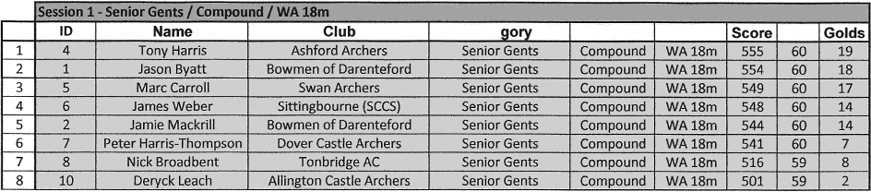

Pos

Cate

Class Round

Hits

